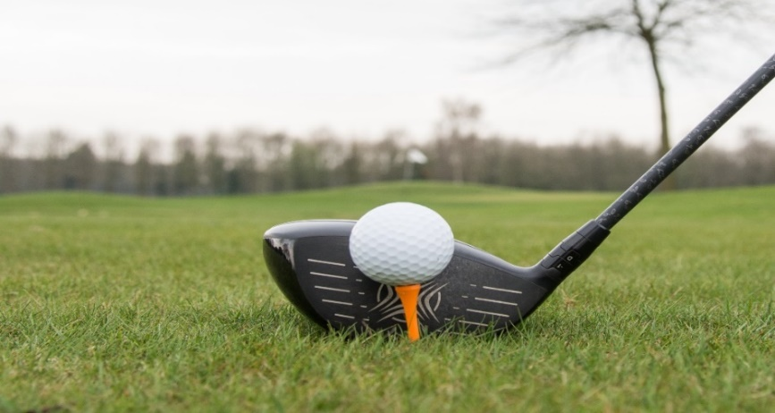
23rd Annual Blue Goose Honker Classic
In aid of Special Olympics Nova Scotia
Thursday, June 1, 2023
Chester Golf and Country Club
222 Golf Course Road Chester NS
Sponsorship Opportunities
*Sponsorship & Payment Deadline – May 15th, 2023*

Hole Sponsorship (not incl meal) $350.00 Hole requested ________
Cost per meal $35.00 Number of meals _______
Tournament Contest Sponsorship:
Closest to the hole _______________ Men ___________ Woman
Longest Drive _______________ Men ___________ Woman
Closest to the line _______________ Men ___________ Woman
Contest of your choice ________________________________
Door Prize Sponsorship _______________ Individual _______ Team
***Please specify prize(s) ________________________________

Name/Company | Telephone# | Contact email
Please send the completed form and indicate payment type below. If paying by cheque or credit, please direct to laura.wamback@svmrestorehalifax.ca and phone # below.
If you are paying by e-transfer, please ensure this form is completed and send this
form with a separate email to nstravelers@gmail.com.
Cheque E-transfer (nstravelers@gmail.com) (Show Sponsorship Bank will send receipt)
Visa/Mastercard call 902-468-3738 and ask for Laura Cheques are payable to Blue Goose Nova Scotia Pond, addressed to ServiceMaster Restore Att: Laura, 90 Simmonds Drive, Dartmouth, NS B3B 1P6
Any questions regarding sponsorship contact tdoane@systemcare.ca

